Blueberry Pancakes Recipe

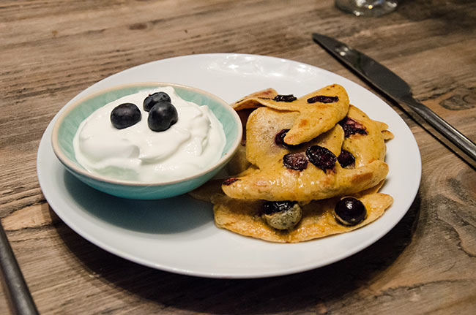

INGREDIENTS
- 2.5 tbsp almond flour (30g)
- 2 medium eggs
- ½ tsp cinnamon
- 60g blueberries, chopped
- 90g Greek Yoghurt (full fat)
- 1 tsp coconut oil

DIRECTIONS
- In a blender, place in the almond flour, eggs and cinnamon and blend until smooth. Then add the blueberries and mix with a spoon.
- In a non stick pan on medium heat, heat up the coconut oil and then place the mixture in small, round pancakes, the size of a jam jar circumference.
- Cook until golden and then turn and cook until the other side is golden and then transfer onto a plate.
- Keep doing this process until all mixture is used. Serve with the Greek yoghurt.

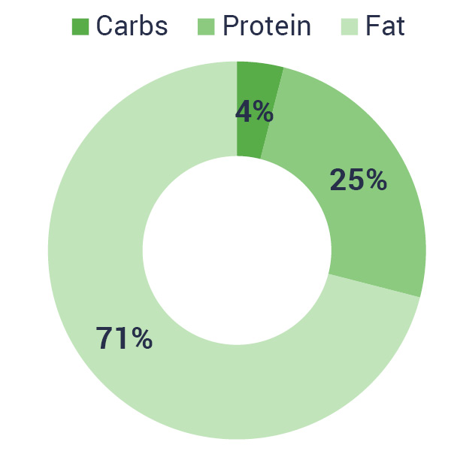
- Kcal: 512
- Carbs: 11.2g
- Protein: 30g
- Fats: 37g
- Fibre: 5.3g

