Lemonade Recipe

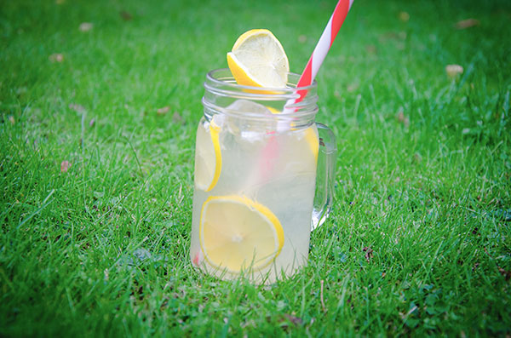

INGREDIENTS
- 1/2 cup sugar
- 1 cup filtered water
- 1 cup freshly squeezed lemon juice
- 4 cups cold filtered water

DIRECTIONS
- In a pan place in the sugar and 1 cup water.
- Bring to the boil stirring constantly until all the sugar has dissolved.
- In a large jug add this mix and all other ingredients and stir.
- Place in the fridge.
- Serve chilled over ice and fresh lemon

