Carrot Cake Recipe

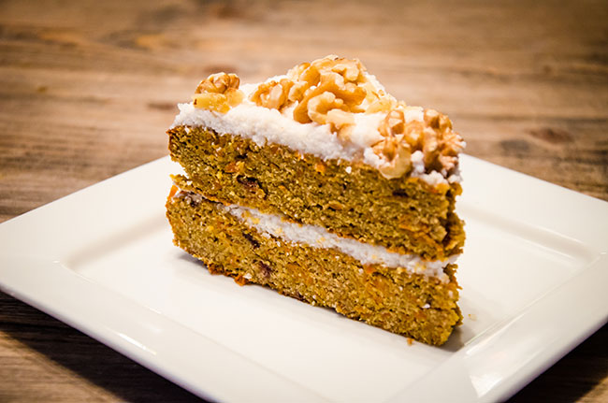

INGREDIENTS
- 5 medium/large carrots, peeled and grated
- 150 ml and 1 tbsp maple syrup
- 120g coconut flour, sifted
- 1 tbsp ground cinnamon
- 1 tsp baking soda
- 1 tsp salt
- 10 eggs
- 12 dates (pitted)
- 1 tbsp vanilla extract
- 100g melted coconut oil

TOPPING
- 200g coconut butter
- 150 ml warm water
- 2 tbsp maple syrup
- Handful crumbled walnuts

DIRECTIONS
- Place the carrots in a bowl and pour over 150ml maple syrup. Cover and leave in the fridge for at least an hour.
- Preheat the oven to 190’C. Add the coconut flour, cinnamon, salt and baking soda to a large bowl and mix. In a food processor blend the dates and 1 tbsp together. Add into this mix the eggs, vanilla extract and coconut oil and blend until all combined. Pour this mixture into the dry mixture bowl and whisk until combined.
- Remove the carrots from the fridge and drain off any excess maple syrup, then stir the carrots into the mixture. Place greaseproof paper into two 9-inch cake tins and evenly place in the mixture into both tins. Bake them both in the oven for 35 minutes, test they are done by placing a knife in the centre, if it comes out clean then it is cooked.
- To make the frosting, you can make your own coconut butter by placing lots of shredded coconut into a food processor and basically blending until it forms butter. Keep scraping the sides down and mix for at least 15 minutes.
- Put 200g of the butter in a food processor and gradually add the hot water until it makes a nice paste and then add the maple syrup. Once the cake is cooled, place some topping on top of one the cakes and then place the other cake on top to make one cake. Then ice the top and crumble over the walnuts.

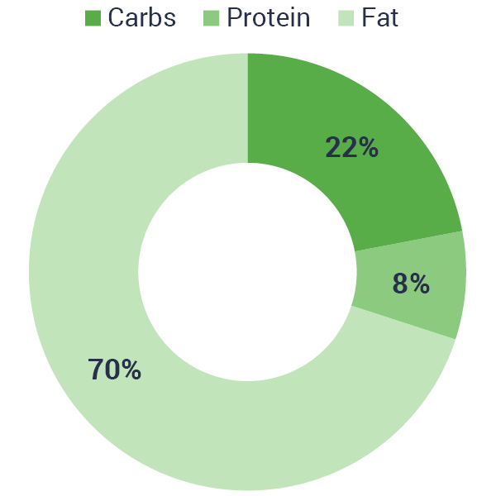

PER PORTION (12 SLICES)
- kcal: 434
- Carbs: 21g
- Protein: 8.6g
- Fat: 33.3g
- Fibre: 6.5g

