Peppers

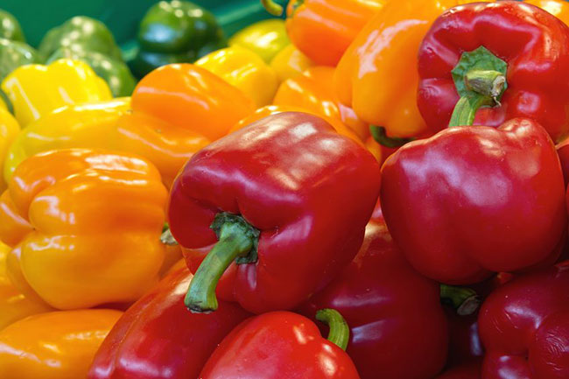
This great variety of vegetables came from central and south America. Bell peppers are generally imported as they are very hard to grow in the UK’s climate. Most come from Spanish farms into the UK. They are such a great vegetable for cooking with as they offer an array of colours and nutrients.

How to store Peppers
These are best stored in the salad drawer of the fridge for up to 2 weeks. They still taste good even if they have wrinkled slightly.

Macro Breakdown per 100g
- Kcal 29.9
- Fat 0.3g
- Carbs 4.8g
- Protein 1g
- Fibre 2g

Nutrient Breakdown per 100g
(RDA – recommended daily allowance)

Vitamins
- Retinol, Carotene 1430µg
- Vitamin A 238µg (101% RDA)
- Folic Acid (B9), Vitamin B12, Biotin (B7) 8.7µg (12% RDA)
- Vitamin C 130mg (213% RDA)
- Tryptophan 10.2mg
- Vitamin K 2.7µg (4% RDA)
- Niacin Total (B3) 0.9mg (6% RDA)
- Vitamin D and E 0.8mg (11% RDA)
- Niacin 0.7mg
- Vitamin B6 0.3mg
- Pantothenic Acid (B5) 0.1mg
- Riboflavin (B2) 0.02mg (6.5% RDA)
- Thiamin (B1) 0.01mg (4.5% RDA)

Minerals
- Potassium 167mg (4.5% RDA)
- Phosphorus 22.3mg (4% RDA)
- Chloride 19.3mg
- Magnesium 13.3mg (3% RDA)
- Calcium 8mg (1% RDA)
- Sodium 4mg (<1% RDA)
- Iron 0.4mg (5% RDA)
- Zinc 0.1mg (2% RDA)
- Manganese 0.1mg (5% RDA)
- Selenium, Iodine 0.7µg (<1% RDA)
- Copper 0.02mg (2% RDA)

How to prepare Peppers
You’ll need to wash, remove the stem, ribs and seeds. I usually do this by standing it up with the stem at the top and cutting downwards from just below the stem to the bottom so you leave the ribs, seeds and stem behind. Otherwise just chop off the stem and half it and then cut out the ribs and remove any seeds.

How to cook Peppers

Raw
No need to cook. Just slice or dice the pepper flesh and add to any salad.

Fry
In a pan with a little oil fry the peppers on a medium heat slowly. Try adding onions and garlic and season. Can take 20 – 30 minutes cooking this way. It can make a great base for sauces and stews.

Stir fried
Add into a stir fry mixture at the end as they only need 4 minutes of cooking.

Oven Roasting
You can either roast them whole or large chunks of flesh. Place in an oven dish at 200’C with a little oil and cook for around 45 minutes until soft.

BBQ
Place whole on a BBQ and turn them every few minutes for around 20 minutes. You can peel the skin off after if you like.

Grilled
Place the flesh under a hot grill for around 20 minutes turning occasionally. Cook until soft.

Ingredients that work well with Peppers
- Anchovies
- Basil
- Marjoram
- Oregano
- Feta cheese
- Mozzarella
- Chilli
- Paprika
- Eggs
- Onions
- Garlic
- Olives
- Tomatoes
- Spinach

