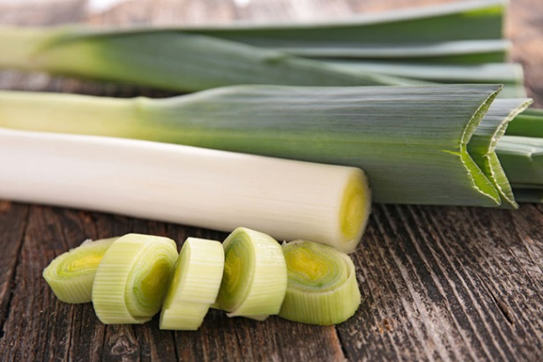

Leeks
This is a winter vegetable and usually in season from September until March. They are part of the Allium family. Potent when raw but turn sweet when cooked.

How to store Leeks
Chop off the tops if they are too long and pop them in the bottom drawer in the fridge for up to a week or a little longer.

Macro Breakdown per 100g
- Kcal 27
- Fat 0.5g
- Carbs 2.9g
- Protein 1.6g
- Fibre 2.2g

Nutrient Breakdown per 100g
(RDA – recommended daily allowance)

Vitamins
- Retinol, Carotene 177µg
- Folic Acid (B9) 56µg (16% RDA)
- Vitamin A 29µg (55% RDA)
- Vitamin C 17mg (20% RDA)
- Tryptophan 12mg
- Vitamin K 10.1µg (39% RDA)
- Biotin (B7) 1.4µg
- Vitamin D and E 0.92mg (6% RDA)
- Niacin total (B3) 0.6mg (2.5% RDA)
- Vitamin B6 0.48mg
- Niacin 0.4mg
- Thiamin (B1) 0.29mg (5% RDA)
- Pantothenic Acid (B5) 0.12mg (3% RDA)
- Riboflavin (B2) 0.05mg (2% RDA)

Minerals
- Potassium 260mg (4% RDA)
- Chloride 59mg
- Iodine 50µg
- Phosphorus 44mg (5% RDA)
- Calcium 24mg (6% RDA)
- Magnesium 3mg (7% RDA)
- Sodium 2mg (1% RDA)
- Iron 1.1mg (26% RDA)
- Selenium 1µg (2% RDA)
- Manganese 0.2mg (2% RDA)
- Zinc 0.2mg (11% RDA)
- Copper 0.02mg (13% RDA)

How to prepare Leeks
Chop off the top darker leaves at the top that are thick that are splaying out and chop off the bottom root at the end. Remove 1 or 2 of the layers. To wash you can either chop first and then wash in a bowl or run a knife down lengthways stopping with an inch to spare at the root end and run under the tap using your fingers to splay out the leaves.

How to cook Leeks

Raw
Only the small slender and young leeks tend to taste good raw in salads. Chop the white and pale green sections into half-moons and add to any salad.

Griddled/BBQ
Cut any large leeks in half, or use whole if small. Cover the leeks in a little oil and salt and place on a hot griddle or bbq. Cook for 4 minutes each side until golden.

Fried
Fry chopped leeks in a little butter or oil slowly on medium heat for a good 15 minutes stirring every few minutes to make sure they don’t stick.

Steam/Boiled
Chopped leeks can be steamed or boiled. Steam for 5 – 10 minutes or until tender or boil in salty water for the same time.

Ingredients that work well with Leeks
- Bacon
- Pancetta
- Chicken
- Salmon
- White fish
- Sea food
- Blue cheese
- Cheddar
- Feta
- Goats cheese
- Sour cream
- Chives
- Mint
- Parlset
- Sage
- Thyme
- Lemon
- Garlic

