Green Bean
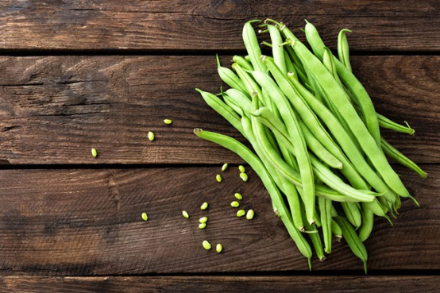
Grown throughout the UK from July to September..

How to store Green Beans
Green beans are best kept in the salad drawer of the fridge in a bag and consumed within a week.

Macro Breakdown
Per 100g (whole)
- Kcal 30.7
- Fat 0.4g
- Carbs 3g
- Protein 2.1g
- Fibre 3.4g

Nutrient Breakdown
Per 100g – (RDA – recommended daily allowance)

Vitamins
- Retinol, Carotene 179µg
- Folic Acid (B9) 58µg (9% RDA)
- Vitamin A 42µg (23% RDA)
- Vitamin K 39µg (12% RDA)
- Tryptophan 24mg
- Vitamin C 8mg (27% RDA)
- Niacin total (B3) 1.2mg (5% RDA)
- Biotin (B7) 1µg
- Niacin 0.8mg
- Vitamin D and E 0.44mg
- Thiamin (B1) 0.12mg (7% RDA)
- Pantothenic Acid (B5) 0.11mg (2% RDA)
- Riboflavin (B2) 0.09mg (8% RDA)
- Vitamin B6 0.06mg

Minerals
- Potassium 286mg (5.5% RDA)
- Chloride 69mg
- Calcium 52mg (3.7% RDA)
- Phosphorus 38mg (6% RDA)
- Magnesium 25mg (6% RDA)
- Iodine 2µg
- Selenium 1µg
- Iron 1mg (13% RDA)
- Zinc 0.4mg (2%)% RDA)
- Manganese 0.31mg (9% RDA)
- Copper 0.06mg

How to prepare Green Beans
It is best to top and tail these either with your fingers or line them up in a row and chop them off. You can also de string them by running a peeler down each side. Don’t forget to rinse them.

How to cook Green Beans

Raw
Best to be used in a salad raw. Thinly slice them to add a nice crunch.

Boiled
Place in a pan of boiling salted water (without a lid) for 4 – 8 minutes.

Stir fry
Finely slice these and add to any stir fry. They only take a few minutes to cook.

Roasted
Pop them in an oiled roasting dish and toss well to cover all with the oil and roast in the oven at 190’C for 30minutes to 1 hour depending how roasted you like them.

Ingredients that work well with Green Beans
- Garlic
- Onions
- Shallots
- Lemon
- Vinegar
- Chilli
- Ginger
- Sesame
- Bacon
- Ham
- Basil
- Tarragon
- Honey
- Almonds
- Anchovies
- Salmon
- Feta
- Olives
- Tomatoes

