Steak and Salsa Recipe

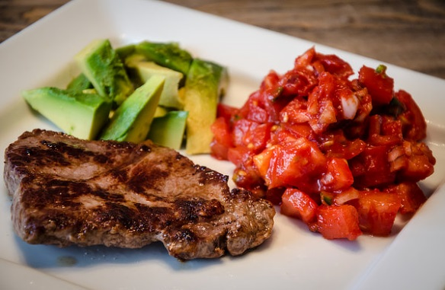

SALSA INGREDIENTS
- 60g Avocado (flesh), chopped
- 110g Sirloin steak
- 1.5 tbsp coconut oil

SALSA INGREDIENTS
- ¼ red onion, finely chopped
- ½ green chilli, finely chopped
- 50g tomato puree

DIRECTIONS
- To cook your steak, place a frying pan on high heat with the coconut oil. When hot place on your steak, keep cooking for 1 minute on each side until cooked until your liking (you can cut into it to see the colour). Place on your plate when ready with the avocado.
- To make the salsa, mix together all the salsa ingredients and then place next to your steak.

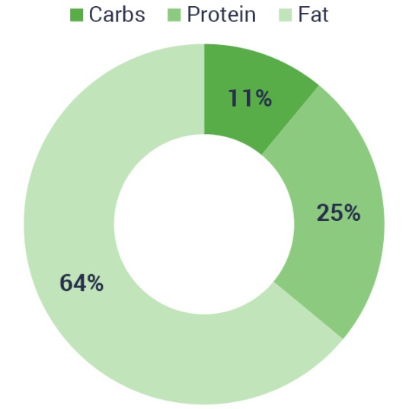
- Kcal: 497
- Carbs: 12.7g
- Protein: 30g
- Fats: 35g
- Fibre: 4.2g

