New Potatoes

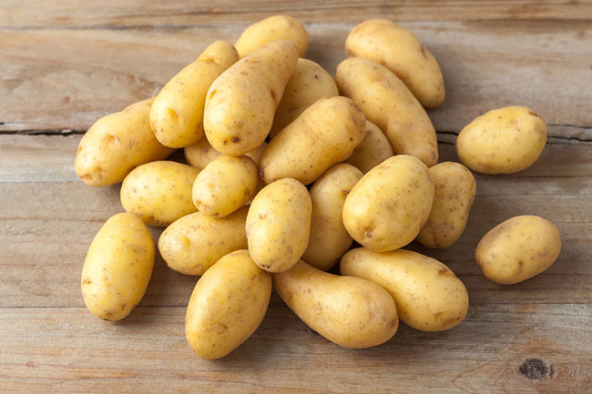
These are usually in season from April to late summer. Early season new potatoes are generally smaller and a little tender, whereas ones later in the season are generally larger and have more flavour.

How to store New Potatoes
These are best kept dirty and in the dark. Leave them in a paper bag and store someone cool or in the fridge.

Macro Breakdown per 100g
- Kcal 70
- Fat 0.1g
- Carbs 14.7g
- Protein 1.8g
- Fibre 1.8g

Nutrient Breakdown per 100g
(RDA – recommended daily allowance)

Vitamins
- Folic Acid (B9) 25µg (4% RDA)
- Tryptophan 24mg
- Vitamin C 7mg (33% RDA)
- Niacin Total (B3) 1.1mg (6% RDA)
- Niacin 0.7mg
- Pantothenic Acid (B5) 0.5mg (6% RDA)
- Biotin (B7) 0.3µg
- Vitamin B6 0.2mg
- Vitamin K 0.2mg (2% RDA)
- Vitamin D and E 0.1mg
- Thiamin (B1) 0.02mg (7% RDA)
Minerals
- Potassium 320mg (9% RDA)
- Chloride 117mg
- Phosphorus 34mg (8% RDA)
- Magnesium 14mg (6% RDA)
- Calcium 6mg (1% RDA)
- Sodium 3mg (0.4 % RDA)
- Zinc 0.2mg (3% RDA)
- Iron 0.1mg (10% RDA)
- Manganese 0.1mg (6% RDA)
- Copper 0.1mg

How to prepare New Potatoes
All you need to do is rinse under a cold tap and lightly scrub the skin to remove any dirt.

How to cook New Potatoes

Boil
Place your potatoes in a pan and cover with cold water and a pinch of salt. Bring it to the boil and then reduce the heat and simmer for around 15 minutes or until cooked through.

Baked
Cut any larger potatoes in half to make them all roughly the same size. Spread them over a baking tray and coat with oil of your choice. Throw in some garlic cloves and rosemary and bake in the oven for around 40 minutes or until cooked turning them a couple of times.

Stove
Place new potatoes in a frying pan with some coconut oil and a splash of water. Cover the pan and cook on a low heat giving the pan a shake occasionally to help stop them stick. Cook until potatoes are tender in the middle (20 – 40 minutes depending on size).

Ingredients that work well with New Potatoes
- Butter
- Mint
- Rosemary
- Dill
- Chives
- Parsley
- Lemon
- Vinegar
- Garlic
- Onions
- Bacon
- Crème fraiche
- Sour Cream
- Eggs
- Fish
- Olives

