Chicken Stew Recipe

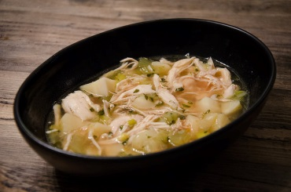

INGREDIENTS
- 1 tbsp coconut oil
- 65g Leeks, chopped
- 3 rashes bacon, chopped
- 3 Garlic Cloves, finely chopped
- 1 stick celery, chopped
- 75g Chicken, diced
- 5 sprigs fresh thyme, chopped
- 500ml vegetable stock

DIRECTIONS
- In a large pan add the coconut oil, leeks, bacon, garlic and celery and stir on a high heat for 5 mins.
- Add the chicken and cook until each piece is white/golden.
- Add the thyme and vegetable stock and bring to the boil, then reduce to a simmer and cook for around 45 minutes or until the chicken is cooked.
- Add salt and pepper to taste.
- This can be batch cooked.

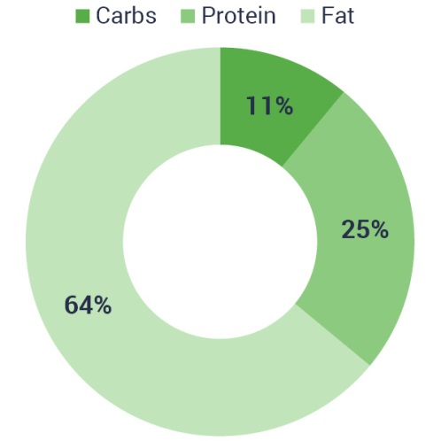
- Kcal: 517
- Carbs: 11.6g
- Protein: 33g
- Fats: 37g
- Fibre: 4.3g

