Sweetcorn
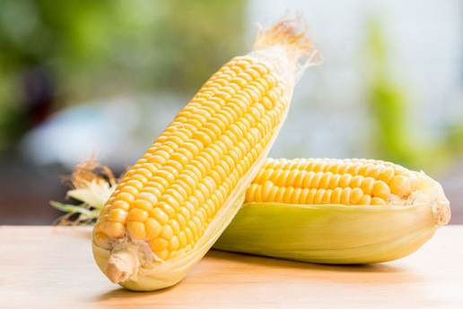
Sweetcorn is a form of maize. In England it is mainly grown in the south. A lot of sweetcorn is genetically modified so buy organically grown corn to avoid this.

How to store Sweetcorn
Sweetcorn is best stored with its husks still attached in the salad drawer of your fridge.

Macro Breakdown
For anyone interested in the macro breakdown here it is per 100g of sweetcorn:
- Kcal 67
- Fat 1.8g
- Carbs 7.4g
- Protein 3.4g
- Fibre 4g

Nutrients
Sweetcorn is a good source of B vitamins such as B3, B6 and pantothenic acid and also Vitamin A. These are great for keeping healthy skin and vision. It contains thiamine which helps produce energy your heart and muscles and riboflavin which helps with good skin and the digestive system.

How to prepare Sweetcorn
Remove the husks by pulling off the leaves and any stringy threads. If you want to remove the kernels then cut lengthways down the sides keeping the knife as close to the core as possible.

How to cook Sweetcorn

Boil
In a pan, bring water to the boil and then add the cobs and cook until tender, it only takes around 4-10minutes, the older the cob, the longer it will take.

Steam
Place in a steamer for 4-10 minutes until tender.

BBQ
Peel back the husks but leave them attached. Remove the silky threads and leave to soak in water for 20 minutes before placing them on the bbq as this prevents burning. Drain and dry the cobs and rub them with oil or butter and seasonings you may like. Place on the bbq and turn regularly until blackened all over, usually around 15 minutes.

Grill
Place under a hot grill with husks and threads removed. Turn regularly until charred all over. Around 15-20 minutes.

Roast
Place in a hot oven of 200’C for 30-40 minutes until tender
Ingredients that work well with sweetcorn:
- Garlic
- Red onions
- Spring onions
- Bacon
- Black beans
- Butter
- Chilli
- Lemon/lime
- Basil, coriander, parsley, thyme
- Squashes
- Tomatoes

