Cottage Pie Recipe

INGREDIENTS
- 2 tsp coconut oil
- ½ small onion, finely chopped
- ½ stick celery, finely chopped
- 1 small carrot, finely chopped
- 40g courgette, finely chopped
- 1 tsp fresh rosemary, finely chopped
- 1 tsp fresh thyme, finely chopped
- 2 cloves garlic
- 140g beef mince
- 2 tsp tomato puree
- 100ml vegetable stock
- 2 bay leaves
- 1 tbsp fresh parsley, chopped
- 120g cauliflower
- ½ tsp butter
- ½ tsp English mustard

DIRECTIONS
- In a large pan on medium/high heat add the coconut oil, onions, celery, carrots, courgette, rosemary, thyme and 1 clove chopped garlic and fry for a few minutes. Add the beef and mix well until browned.
- Once browned stir in the tomato puree and mix well and then add the stock and bay leaves. Leave this to simmer for around 20 minutes until the liquid gets a little thicker. Stir in the parsley and add salt and pepper to taste.
- Preheat oven to 200’C. Chop the cauliflower into medium florets. Add the cauliflower and the remaining clove garlic (whole) and simmer with a little water in the bottom for 5 minutes or until tender with a lid on. Drain and mash adding the English mustard, butter and a little salt and pepper. Mash until smooth.
- Take a small oven dish and place in your mince mixture and then cover with the cauliflower mash and use a fork to move the mash to cover the mince and make flat. Bake in the oven for 25-30 minutes until it’s golden.

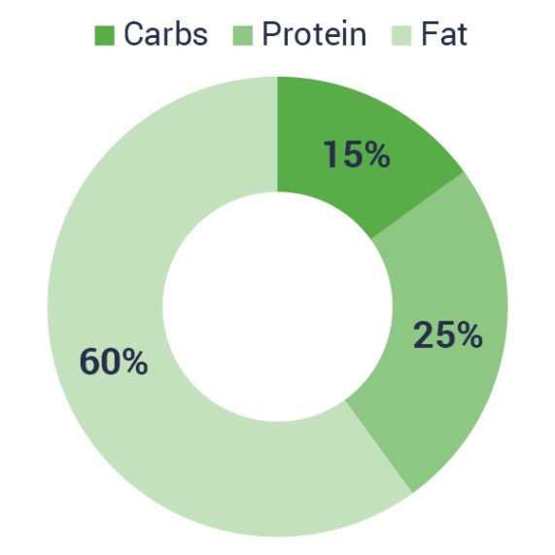
- Kcal: 553
- Carbs: 20g
- Protein: 35g
- Fats: 36g
- Fibre: 8.7g

