Chicken Stock Recipe

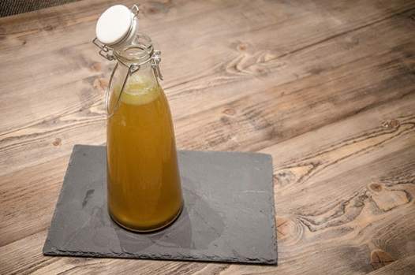

INGREDIENTS
- 2kg raw chicken carcasses (ask your butcher)
- 2 Sticks celery chopped
- 2 leeks, chopped
- 2 onions chopped
- 2 carrots chopped
- 3 stems fresh rosemary
- 4 stems ½ bulb garlic, bashed
- fresh parsley
- Salt and pepper
- 1 tbsp cider vinegar
- Salt and pepper

DIRECTIONS

Place all ingredients in a large deep pan and cover with enough water so everything is covered. Add some salt and pepper.
Bring to boil and then leave to simmer with the lid on for 4 hours. Skim the top if needed.
Leave to cool and place in a glass container. Keep in the fridge for up to 4 days or freeze.

