Orange & Vanilla Water Recipe

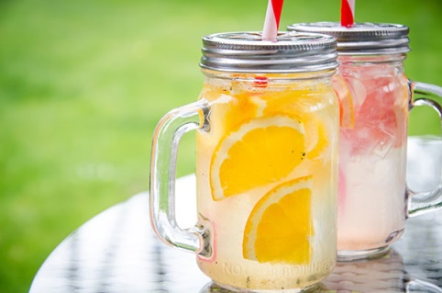

INGREDIENTS
- 2 Oranges
- Vanilla Bean
- Still/Sparkling Mineral Water
- Ice

DIRECTIONS
- In a jug squeeze the juice in from 2 oranges and also cut up 2 oranges into segments and place into the jug.
- Cut a vanilla bean in half and scrape in the seeds.
- Add ice and cover with still or sparking mineral water and mix well.

